Ideation Phase

Define the Problem Statements

|  |  |
| --- | --- |
| Date | 10 Nov 2022 |
| Team ID | PNT2022TMID46314 |
| Project Name | Project — Real-Time Communication System Powered By AI For Specially Abled |
| Maximum Marks | 2 Marks |

**PROBLEM STATEMENT:**

Communication between the specially-abled and the ordinary people has always been a challenging task. Especially, the way of communication between people with disabilities cannot be easily learned by Ordinary people.

Since communication needs to be faster and accurate. This system should also covey the message in case of emergency. Moreover, the message should be transferred from one person to another without any change in the content.

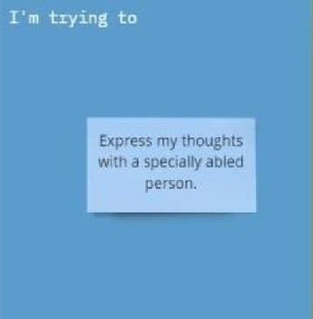an ordinary person.

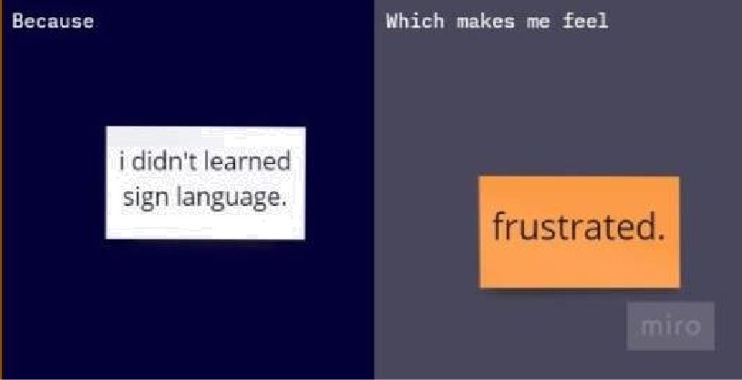d Onr k n ow

sign language.

|  |  |  |  |  |  |
| --- | --- | --- | --- | --- | --- |
| Problem  **Statement (PS)** | **I am**  (Customer) | **I'm trying to** | **But** | Because | Which makes me feel |
| PS-1 | An ordinary  person | Express my  thoughts with a speciallyabled person. | I don't  know sign language | I didn't  learned sign language | Frustrated. |

|  |  |  |  |  |  |
| --- | --- | --- | --- | --- | --- |
| PS-2 | Specially abled person | Communicate with an  ordinary person | it's difficult to express | The  ordina ry person doesn't know sign language | Frustrated. |